**BUSINESS REQUIRMENT DOCUMENT FOR**

**Online Healthcare Appointment Booking System**

**SELVASEKAR M**

**Table of Content**

|  |  |  |
| --- | --- | --- |
| **S. L** | **Topic** | **Page No** |
| 1. | Document Control | 3 |
| 2. | Executive Summary | 4 |
| 3. | Business Objective | 4 |
| 4. | Project Scope | 4 – 5 |
| 5. | Stakeholder Identification | 6 |
| 6. | Assumption & Constraints | 5 |
| 7. | Problem Statement & Current Challenges | 6 |
| 8. | Requirements | 6 – 7 |
| 9. | Process Flow Diagrams | 8 – 9 |
| 10. | Wireframes | 9 – 11 |
| 11. | Glossary and Terms | 12 |
| 12. | Approval & Sign-Off | 13 |

**Document Control**

|  |  |
| --- | --- |
| **Field** | **Details** |
| Document Title | Business Requirements Document (BRD) |
| Project Name | Online Healthcare Appointment Booking System |
| Created By | SELVASEKAR M |
| Created On | 12-05-2025 |
| Version | 3.4 |
| Last Updated On | 04-06-2025 |
| Status | Complete |
| Approved By | N/A |

**1. Executive Summary**

The Online Healthcare Appointment Booking System is a proposed digital solution aimed at simplifying the process of scheduling appointments between patients and healthcare professionals. This system will allow patients to view available doctors, check their availability, and book appointments directly through a user-friendly web interface.

The main goal of this project is to replace traditional, manual appointment booking methods with an efficient and accessible platform that can reduce wait times, eliminate human error, and improve overall patient experience. The system will include features like doctor listings, patient registration, appointment scheduling, and confirmation via email or SMS.

This document outlines the business needs, scope, requirements, and expectations for the development of this system. It is intended to serve as a communication bridge between business stakeholders and technical teams throughout the Software Development Life Cycle (SDLC).

**2. Business Objective**

The primary objective of the Online Healthcare Appointment Booking System is to enhance the efficiency and convenience of scheduling medical appointments. This system will help bridge the communication gap between patients and healthcare providers by offering an intuitive platform that supports real-time appointment booking, rescheduling, and cancellation.

The goal is to:

* Minimize patient wait times
* Reduce manual errors in appointment tracking
* Provide transparency in doctor availability
* Improve operational efficiency for clinics and hospitals

This system aims to serve as a stepping stone towards a more digital and patient-centric healthcare experience.

**3. Project Scope**

This project focuses on designing and developing a web-based healthcare appointment booking system. The system will allow patients to register, browse available doctors by specialty, view doctor availability, and book or cancel appointments online. Doctors and administrators will be able to manage their schedules and monitor appointment bookings.

**3.1 In scope**

* Patient registration and login
* Doctor profile viewing and search
* Appointment booking, rescheduling, and cancellation
* Notifications or confirmations via email or SMS

**3.2 Out of Scope:**

* telemedicine or video consultations
* Integration with real-time hospital ERP systems
* Payment processing or billing systems
* Mobile application development (this version is web-only)

**4. Stakeholder Identification**

The success of this system depends on understanding and addressing the needs of all key stakeholders involved in the appointment booking process. The primary stakeholders for this project are:

* **Patients** – End-users who book appointments with doctors using the system. Their primary needs include ease of use, availability information, and booking confirmations.
* **Doctors** – Healthcare providers who offer consultation services. They need control over their schedules and visibility into upcoming appointments.
* **Receptionists/Admin Staff** – Internal clinic users who help manage appointment records, cancellations, and doctor availability.
* **System Administrator** – Responsible for managing user roles, system settings, and data privacy compliance.

Each of these stakeholders has specific goals and expectations that will guide the system’s design and functionality.

**5. Assumptions & Constraints**

**5.1 Assumptions:**

* Users will have access to the internet and a smartphone or computer to use the platform.
* Doctors and receptionists are available and trained to manage their appointments through the system.
* Basic healthcare information and services will be available to patients via the system.
* Admins will monitor and update doctor availability and clinic hours as needed.

**5.2 Constraints:**

* The system will initially support only English language.
* Integration with third-party systems (like insurance or pharmacy) is out of scope for the first release.
* The project is limited by time and will be developed as a prototype for demonstration purposes.
* Real-time video consultations are not included in the MVP (Minimum Viable Product).

**6. Problem Statement & Current Challenges**

**6.1 Problem Statement:**

In many small to mid-sized clinics, patients still book appointments by calling the reception or walking in directly. This leads to long wait times, overlapping bookings, and administrative burden on staff. Patients often struggle to check doctor availability or reschedule appointments efficiently.

**6.2 Current Challenges:**

* Manual appointment booking leads to scheduling errors and confusion.
* Patients cannot check doctor availability or cancel appointments online.
* Receptionists spend excessive time on phone calls and manual updates.
* There is no centralized system to track patient visits, appointment history, or doctor schedules.
* Lack of automated reminders results in missed appointments.

**7.Requirements**

**7.1 Functional Requirement**

**7.1.1 User Registration & Login**

* Patients, doctors, and receptionists can register and log in securely.
* Password reset and profile management features are available.

**7.1.2 Appointment Management**

* Patients can view doctor availability and book appointments online.
* Receptionists can create, modify, or cancel appointments on behalf of patients.
* Doctors can view their daily schedule and appointment details.

**7.1.3 Notifications & Reminders**

* Automated email/SMS reminders are sent to patients for upcoming appointments.
* Notifications are sent to doctors and receptionists for schedule changes or cancellations.

**7.1.4 Search & Filter**

* Patients can search doctors by specialty, location, and availability.
* Appointment slots are shown in real-time to avoid double bookings.

**7.1.5 Dashboard**

* Doctors and receptionists have dashboards summarizing upcoming appointments and patient info.
* Patients can view their appointment history and upcoming bookings.

**7.1.6 Feedback & Ratings**

* Patients can provide feedback or rate their appointment experience.
* Doctors and receptionists can view feedback reports.

**7.1.7 Security & Data Privacy**

* All sensitive data is stored securely following healthcare data privacy standards.
* Access controls ensure users see only relevant information based on their role.

**7.2 Non – Functional Requirement**

**7.2.1 Performance**

* The system should load the appointment booking page within 3 seconds under normal network conditions.
* The backend should handle up to 100 simultaneous user logins without lag.

**7.2.2 Availability**

* The system should maintain 99.9% uptime during clinic working hours.
* Maintenance windows will be scheduled during off-hours and communicated in advance.

**7.2.3 Security**

* All user data should be encrypted during transmission and storage.
* Role-based access control should ensure only authorized users can access sensitive data.

**7.2.4 Usability**

* The interface should be intuitive and user-friendly, with easy navigation for non-technical users.
* The system should support accessibility features like screen readers and keyboard navigation.

**7.2.5 Scalability**

* The system should be scalable to support more clinics or doctors as the organization grows.
* Database and infrastructure should allow seamless upgrades without downtime.

**7.2.6 Data Backup & Recovery**

* Daily automated backups must be taken to prevent data loss.
* The system should support data recovery within 2 hours in case of failure.

**8. Process Flow Diagrams**

**8.1 Patient Appointment Booking Flow**

**8.2 Admin/Receptionist Appointment Management Flow**

**9. Wireframes**

The following wireframes represent key screens of the Online Healthcare Appointment Booking System. These visuals help stakeholders understand the basic layout and design of the user interface from a user’s perspective. Wireframes were created using Miro and serve as early design references. They are subject to changes based on stakeholder feedback and development needs.

**9.1 Login / Signup**

This wireframe represents the entry point for users. It includes both login and signup options with essential fields like Email, Password, and an OTP verification feature. It ensures a smooth and secure onboarding process.

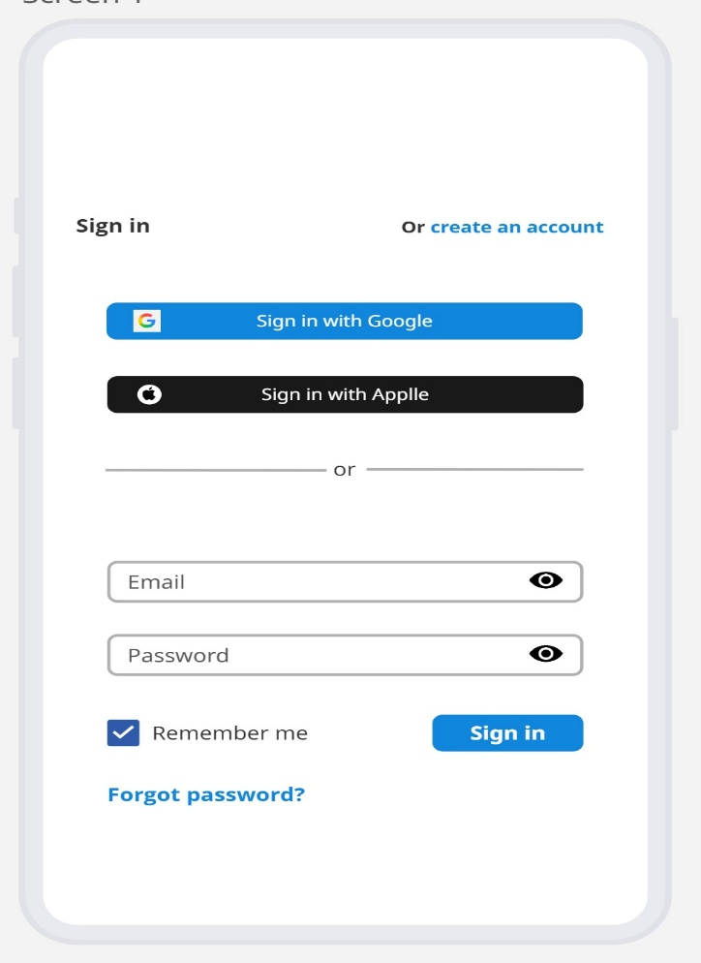

**9.2 Appointment Booking Page**

This screen allows users to search for doctors by specialty or availability and book appointments accordingly. It displays available slots and includes options for filtering, selecting time, and confirming the booking.

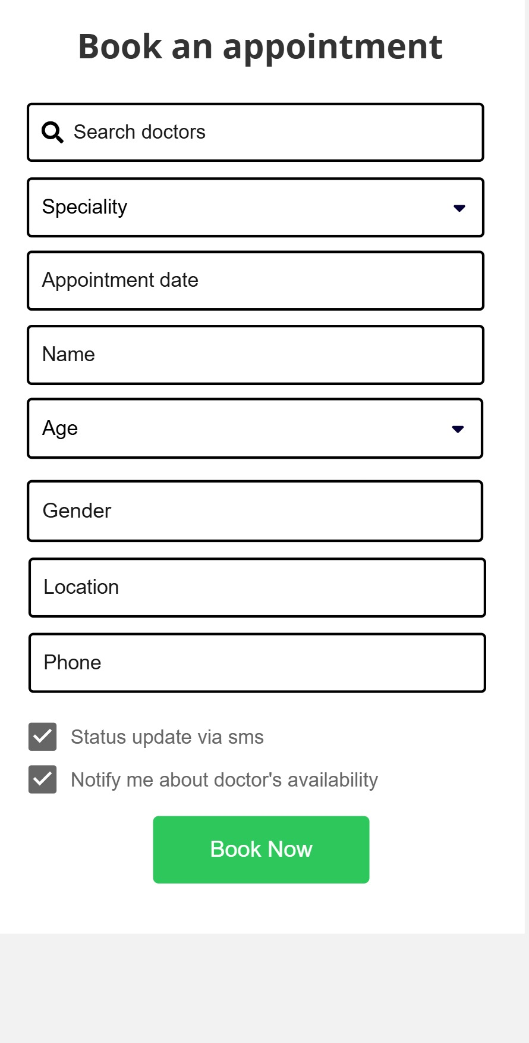

**9.3 User Dashboard**

The user dashboard shows upcoming appointments, appointment history, and rescheduling or cancellation options. It acts as the central hub for users to manage their bookings and preferences.

**10. Glossary of Terms**

|  |  |
| --- | --- |
| **Term** | **Definition** |
| BRD | Business Requirements Document – A detailed document listing all project needs |
| UI | User Interface – The visual layout or design users interact with |
| Dashboard | A summary screen showing user-specific information and actions |
| Slot | A specific time period for doctor appointments |
| OTP | One-Time Password – Used for secure login/signup |
| Stakeholder | Any person or group affected by the project outcome |
| Backend | The server-side logic that supports front-end functionality |
| Wireframe | A basic visual representation of a screen layout |
| Functional Requirement | A feature or task the system should perform |
| Non-Functional Requirement | A quality or constraint like performance, security, or usability |

**11. Approval & Sign-Off**

|  |  |  |  |  |
| --- | --- | --- | --- | --- |
| **Name** | **Designation** | **Organization** | **Signature** | **Date** |
| Dr. Ravi | Chief Medical officer | ABCD Hospital |  |  |
| kavitha | Product Owner | XYZ Limited |  |  |